Software Requirements Specification

Prepared by   
Shiv Bajpai  
U101114FCS131  
B.Tech CSE

**1. Introduction**

**1.1 Purpose**

Agile Development System is an open software which will help the Development team to design the product. Agile carries out the assessment of the project all throughout the product development life-cycle.

**1.2 Document Conventions**

This document is based on IEEE standard with the font ‘ARIAL’ and heading size of 20, subheading size of 14 and content of size 12.

**1.3 Intended audience and reading suggestions**

This document is particularly intended for all the sectors like - IT, film industry, business management, software development companies, Board of directors, Managers, department hierarchies for maintaining the product’s development at different phases.

**1.4 Product scope**

With every passing day we have seen more and more of agile in broader product development in sales and marketing departments. This change will help industries of any genre to use this product and will facilitate better understanding of development to their customers and even their employees.

**1.5 References**

IEEE. *IEEE Std 830-1998 IEEE Recommended Practice for Software Requirements*

*Specifications.* IEEE Computer Society, 1998.

**2. Overall Description**

**2.1 Product Perspective.**

The Agile based Product Development Software is a unique system which will divide things in organizational hierarchy, and helps in forming the development timeline required for the completion of the product. The use case diagram in Figure 1 illustrates the external entities and system interfaces for release 1.0.

**2.2 Product Functions.**

Agile-PDS provides a user-interface to the firm’s manager and its customer to see the production time-line of the final product. It also provides an interface to the employees working under the product development team to input the further work progress of the modules.

**2.3 User Cases and Characteristics.**

Customer The actor who is defining the product specification to the

Manager/HRD, which in turn is defining modules for the

product.

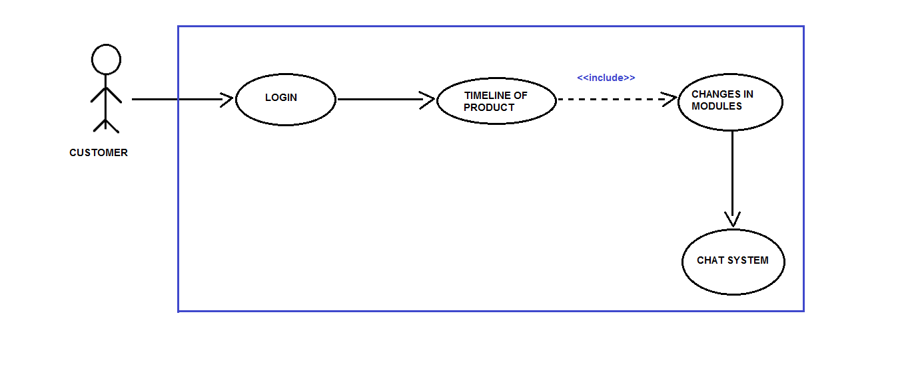

Figure 1.1

Manager/HRD

The actor who is responsible for the commencement

of the product development phase, which he does through the system’s

interface provided to him. Manager/HRD first login’s with its credentials

then can either view the earlier created tasks or creates a new

one. Manager/HRD then defines the module's(objectives) according to

the customer’s requirements of the product.Manager/HRD is also

responsible for the assignment of the modules to their respective

product development team(PDT).

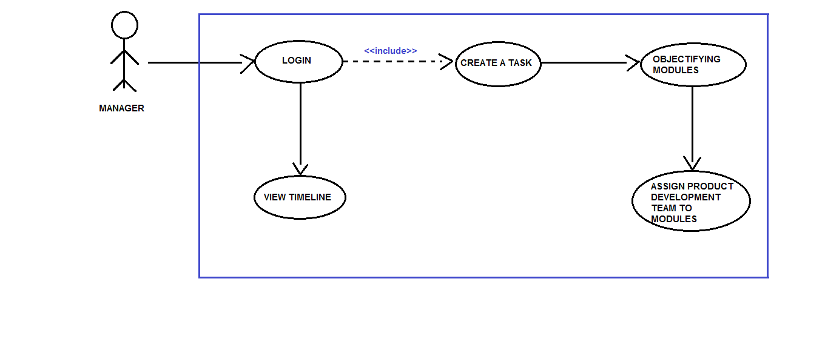

Figure 1.2

Employee The employee working in the PDT is the actor who is responsible for

the daily reporting on his assigned module by the

Manager/HRD. Employee is also responsible for the changes done to

the modules according to the customer. An employee can get its

objectives much clearer by communicating directly through the

Customer by Chat/Commenting service of the system.

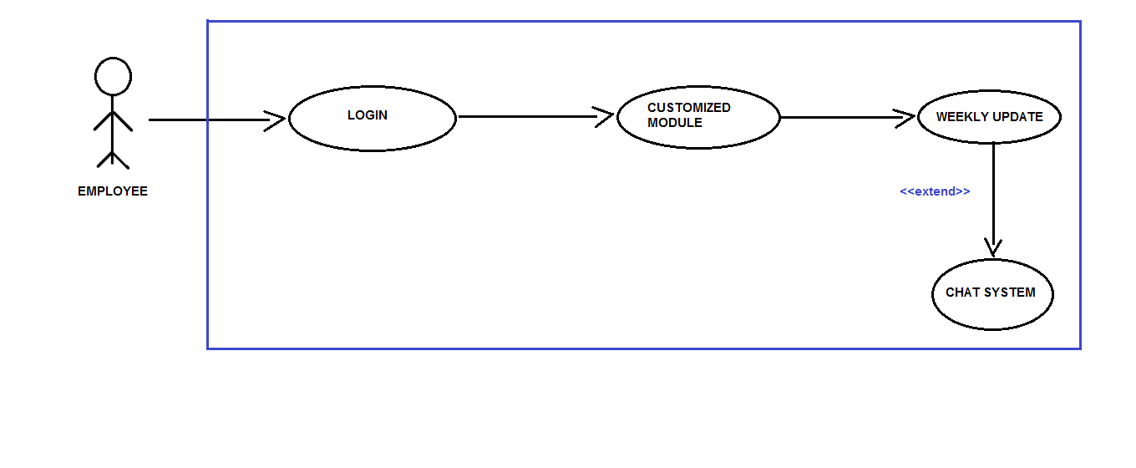

Figure 1.3

**2.4 Operating Environment.**

OE-1 The Agile-PDS shall operate with the following web browsers:

Google Chrome Version-53 or latest.

OE-2 The Agile-PDS shall operate on a server running the current corporate

approved versions of Apachetomcat 8.0.

OE-3 The Agile-PDS shall permit employee access from the firm’s intranet,

and if the employee is allowed for the outside access through the firm’s

firewall, from an internet connection at employees remote location.

OE-4 The Agile-PDS shall have a hosted interface on the internet for the

customer.

**2.5 Design and Implementation Constraints.**

CON-1 The system shall use the current corporate standard of Mysql engine InnoDB.

CON-2 The system shall use the current corporate standard of Nosql with Json.

CON-3 All HTML code shall conform to HTML 5.0 standard.

CON-4 All scripts shall be written in JavaScripts.

CON-5 The system’s design,code and maintenance shall follow the Eclipse Neon Java EE tools.

**2.6 User Documentation.**

UD-1 The system shall provide an online hierarchical and cross-linked help

system in HTML that describes and illustrates all system functions.

UD-2 The first time customer when accesses the system, on demand it will

be given Information regarding the User Interfaces.

**2.7 Assumptions and Dependencies.**

AS1 The final product made by the firm is feasible according to their

standards.

DE1 The operation of Agile-PDS depends on the firm’s Manager/HRD who

is responsible for the creation of the task and defining its modules,later

assigning it to the product development team.

DE2 The operation of Agile-PDS depends on the employees working in

product development team inputting their work progress which helps in framing the timeline of the final product.

DE3 The operation of Agile-PDS depends on the customer in regular

commentation and communication about the final product’s

modules/goals.

**3. External Interface Requirements**

**3.1 User Interfaces:**

UI 1: The XYZ screen will display a login page with a dropbox, where there can be three different types of personnels entering their respective **username and password**. After entering their credentials, there can be be three different pages for Customers, Development Team and Employees, this will be facilitated with the help of the dropbox.

UI(for Customers): The customers can see the progress and the timeline for the respective project. Also there will be a **chat system,** if there are any messages for any of the teams, the same can be conveyed through the chat system.

UI(for manager):  The manager/HRD can create a new project, set the modules, assign teams to these modules and specify the timeline within which all this work is supposed to be done.

UI(for Development team): The personnel in the Development team can update their project progress/report, time to time. They can also send and revert messages through the **chat system**, if needed.

**3.2 Hardware Interfaces.**

No hardware interfaces have been identified.

**3.3 Software Interfaces.**

SI1 Chat System/Commenting Service.

SI1.1 Chat System is responsible for sending the comments provided by the

Customer to its designated employee working on that particular

module.

SI1.2 Chat System can also be utilized by the employee in clearing its

objectives while designing/implementing its module.

**3.4 Communication Interfaces.**

CI-1 The Agile-PDS should send an email to the customer on creation of the

task and about its modules.

CI-2 The Agile-PDS should send an email to the customer to report any

problems with the modules(objectifying goals).

**4. System Features**

**4.1 Creating a Task**

**4.1.1 Description and Priority**

Agile PDS whose identity has been verified and is right now one of the most stable platform for the development of any product or software. Its main purpose is to ease and fasten the communication link between the manager and employees, employees and customers.

**4.1.2 Functional Requirements**

|  |
| --- |
| **task.name:** The name of the task must be decided and shall be posted by manager whenever he wish to create his new task and shall be shared among the PDT.  **Task.customer_name :** the name of the customer who has given the task must be written while creating the modules.  **Task.company_name :** name of the company to which customer belongs shall be provided. |
| **Task.create_modules :** manager shall create the modules based on the product specification which that company requires.  **Task.assignment _of_product_to_PDT :** Manager shall assign the task as per the specification of the team. |
| **Task.timeline :** Basically this will let customer to see the whole levels that till what stage the product is finished and which team is currently working at that moment.  **Task.changes_in_modules :**  Customer shall ask for some changes if its not according to his requirements.  **Task.chat_system :** Using this chat system customer can give update about the changes whether it's okay or not and relating to his response the team can look after that query. |
| **Task.customized _module :** employee shall work on the allotted module related to his profile.  **Task.weekly_update :** employees should weekly update the modules on the basis of the **Task.chat_system** according to the customer requirements. |

**4.2 Creating a module**

**4.2.1 Description**

Creation of modules on the basis of customer requirements is done by the manager and during this process he will assign the product development team to all the specified modules according to their field of working or the field which suits the particular employee best.

**4.4 Assigning modules to PDT**

**4.4.1 Description**

During this phase of development when all the modules are created and

designed then the team will be assigned to the modules who will work in the development process of that particular work. This team will also help in modifying the product on the weekly basis with respect to the changes

required by the customer after putting the request in the chat system box.

**5. Other Non-Functional Requirements**

Our goal is to minimize the effort during the course of development and test out the performance and functionality in the same time frame, so as to reduce the capital required to incorporate changes at the later stages of the development.

**5.1 Performance Requirements**

**Real Time Tracking:**The system would track the progress of all of the efforts that are being put into the project in real time. So, we would need to ensure that this system works properly at all stages, implying that it should continuously keep a track of the records of the developers and their contribution to this project.

**Transparency/Clarity of Communication:** This data would be made visible to the Human Resources Department, the Project Manager as well as the developers who are working on this project such that there is a hundred percent transparency rate during the workflow.

**5.2 Safety Requirements**

**Periodic Backups/Recovery:** In case if any situation arises where the data is being completely lost, we will ensure that a backup of the entire project is taken into the server, preferably the Cloud, beforehand.

**5.3 Security Requirements**

**Preventing Data Leakage:** There would be a strong requirement to secure the data and protect the privacy of the users as well as the developers at the same time. So a strong need would arise to protect the huge amount of data from being destroyed or manipulated by malicious users such as black-hat hackers and crackers.

**5.4 Software Quality Attributes**

**Availability:** The system will be available to the users as well as the developers anytime during the day, so as to view their progress report.  
**Consistency and Reliability:** The system will be designed to become consistent and not fail at any given point of time, even if it does then we will have counter measures to rectify the system, then and there itself.

**5.5 Business Rules**

* Every individual must be self-reliant and self-directed, they should also have enough trust amongst fellow colleagues in order to complete the project.
* There would not be any miscommunication from either of the person involved in this project, we would be implementing a more efficient and effective means of communication between the individuals